Project Design Phase-II

Data Flow Diagram & User Stories

|  |  |
| --- | --- |
| NM ID | 76860632B2D43EFBE814FEC16F13E5E4 |
| Project Name | How To Add Google Analytics To A Website |

# Data Flow Diagrams:

A Data Flow Diagram (DFD) is a traditional visual representation of the information flows within a system. A neat and clear DFD can depict the right amount of the system requirement graphically. It shows how data enters and leaves the system, what changes the information, and where data is stored.

Example: Data Flow Diagram [(Simplified)](https://developer.ibm.com/patterns/visualize-unstructured-text/)

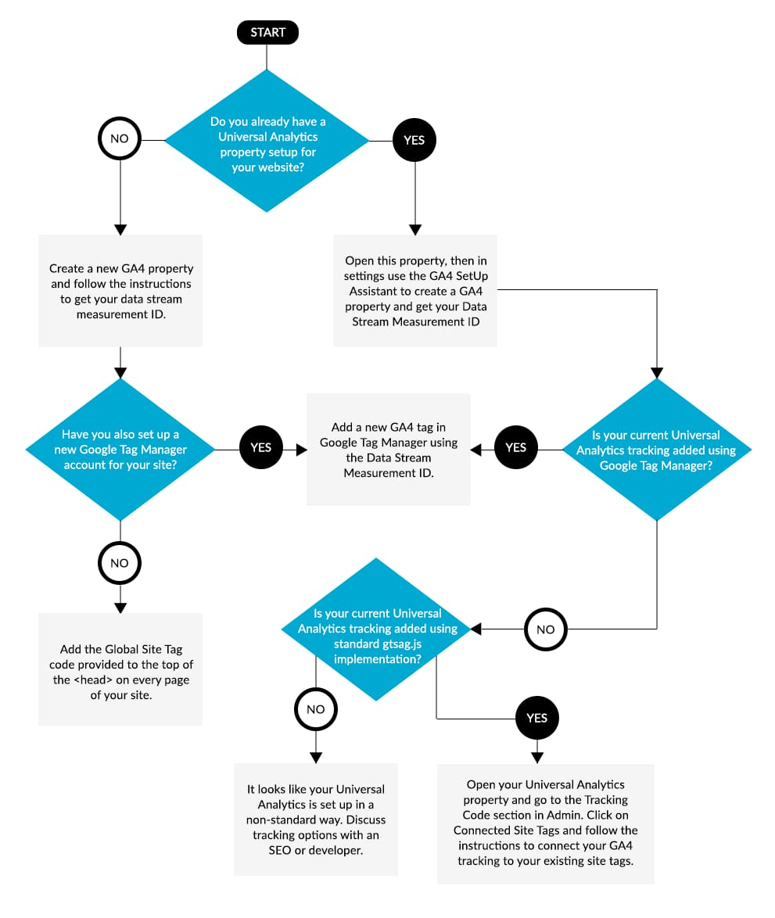

|  |  |  |  |  |  |  |
| --- | --- | --- | --- | --- | --- | --- |
| **User Type** | **Functional Requirement (Epic)** | **User Story Number** | **User Story / Task** | **Acceptance criteria** | **Priority** | **Team Member** |
| Customer(website user ) | Registration | USN-1 | As a user once I visited the website for sign up I will enter the credentials like name, email id, password etc.... | I can access my account in Google | High | Musica |
|  |  | USN-2 | As a user I can also signup with my Google account. | I can receive confirmation email & click confirm | High | Narmatha |
|  |  | USN-3 | As a user, I can register for the application through social medias. | I can register & access the dashboard with Facebook Login | Medium | Vishalini |
|  |  | USN-4 | As a website residient,I want to report website issues so that they can be addressed by the local authorities. |  | Medium | Suriya shri |
|  | Login | USN-5 | Once I get registered, I will receive a confirmation mail. | I can register & access the dashboard with Facebook Login | High | Musica |
|  | Dashboard | USN-6 | By login I will get into the website dashboard. | All the information about the website are given in the dashboard. | High | Narmatha |
| Performance | Registration | USN-7 | As a user, I will receive confirmation email once I have registered for the application | By giving this credential  details I can access my account or Dashboard. | Low | Vishalini |
|  |  | USN-8 | As a user once I visited the website for signup I will enter the credentials like name, email | Through confirmation mail I have get into the  website | Medium | Suriya shri |
| Analysis | Registration | USN-9 | As a user I can also signup with my Google account. | By entering my Facebook details I can get sign in  with the website. | Low | Musica |
|  | Login | USN-10 | After getting signup, I can login into the website by entering the email and password. | Once I get the login I can enter the dashboard of the website. | High | Narmatha |
| Administrator | Maintenance | USN-11 | As a administrator I can maintain all the activities of the website. | Administrator must maintain all activities of both the all performance. | Medium | Vishalini |